# **Mastering Autovacuum and Vacuum in PostgreSQL: The Complete Guide for DBAs**

[](https://medium.com/@jramcloud1?source=post_page---byline--fba18c2b2477---------------------------------------)

[Jeyaram Ayyalusamy](https://medium.com/@jramcloud1?source=post_page---byline--fba18c2b2477---------------------------------------)

Following

23 min read

·

Jun 21, 2025

13

Press enter or click to view image in full size

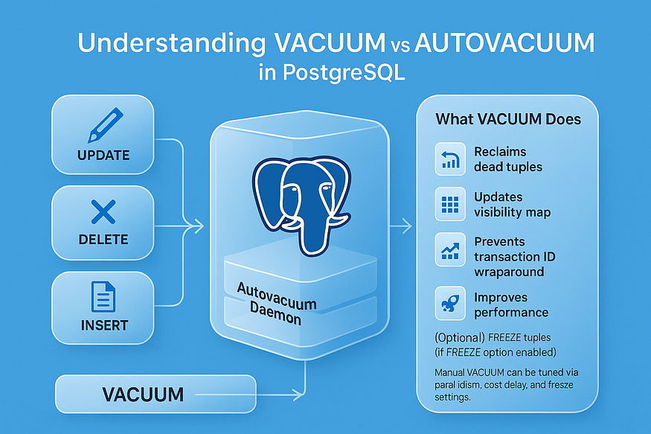

## **🧹 PostgreSQL Vacuum & Autovacuum: The Silent Guardians of Your Database**

PostgreSQL is renowned for its reliability and performance, but what truly keeps it fast and lean under the hood is its ****vacuuming mechanism****. Whether you’re running a high-traffic web application or managing enterprise-scale analytics, understanding ****VACUUM**** and ****AUTOVACUUM**** is essential for keeping your PostgreSQL database healthy.

## **🔄 Why PostgreSQL Needs Vacuuming**

PostgreSQL uses a ****Multi-Version Concurrency Control (MVCC)**** model. This means every time a row is updated or deleted, the old version of the row isn’t immediately removed — instead, it’s marked as ****dead**** and remains in the table. These dead rows, also known as ****dead tuples****, are invisible to future transactions but still consume storage space and slow down sequential scans.

Over time, this can lead to ****table bloat****, degraded query performance, and even critical failures if not managed properly. That’s where the ****VACUUM**** process comes into play.

## **🧽 VACUUM: The Manual Cleaning Agent**

The VACUUM command scans your tables and reclaims space occupied by dead tuples. It also updates visibility maps and statistics so the query planner can work efficiently.

However, VACUUM does ****not**** immediately shrink the size of the physical table file. For that, you'd need VACUUM FULL, which compacts the table but comes with heavy locks and higher I/O.

-- Basic vacuum  
VACUUM;

-- Vacuum with analyze for planner stats  
VACUUM ANALYZE;

Use VACUUM during off-peak hours if you're managing it manually — especially on large tables.

## **🤖 AUTOVACUUM: The Background Hero**

Since manual vacuuming isn’t practical for dynamic databases, PostgreSQL runs ****autovacuum workers**** in the background. These processes automatically:

* Reclaim space by vacuuming dead tuples.
* Prevent ****transaction ID (XID) wraparound****, which could otherwise corrupt your data.
* Run ANALYZE to update statistics for the planner.

Autovacuum thresholds are based on table activity. PostgreSQL tracks insert, update, and delete operations. Once certain limits (autovacuum_vacuum_threshold + autovacuum_vacuum_scale_factor * reltuples) are crossed, it triggers autovacuum for that table.

## **⚠️ Transaction ID Wraparound: A Hidden Time Bomb**

Every row version in PostgreSQL is stamped with a ****transaction ID (XID)****. But XIDs are 32-bit numbers and will eventually wrap around to zero (~4 billion transactions). If old tuples aren’t vacuumed, PostgreSQL won’t be able to determine visibility correctly — risking ****data loss****.

Autovacuum is your first and last line of defense here. Without it, your database could ****refuse writes or shut down entirely****.

## **🛠️ Best Practices**

* ****Never disable autovacuum****, even if you’re manually vacuuming.
* Monitor pg_stat_all_tables and pg_stat_user_tables to check dead tuples.
* Adjust autovacuum settings (autovacuum_naptime, autovacuum_vacuum_cost_limit) for high-write workloads.
* Use pg_stat_activity and logs to identify long-running autovacuum operations.

## **🚩 The Problem: Dead Tuples & Table Bloat in PostgreSQL**

PostgreSQL is often praised for its robust performance, support for concurrent operations, and strong transactional integrity. A key technology that enables this is ****MVCC (Multi-Version Concurrency Control)****. However, while MVCC solves concurrency challenges brilliantly, it introduces a hidden challenge: the accumulation of ****dead tuples****, which leads to a problem known as ****table bloat****.

In this section, we’ll demystify how dead tuples are formed, why they matter, and how they impact PostgreSQL performance over time.

## **🔍 What is MVCC and Why Does PostgreSQL Use It?**

PostgreSQL’s ****MVCC**** architecture allows multiple transactions to access and modify the database ****without blocking each other****. When you perform an UPDATE or DELETE, PostgreSQL doesn’t overwrite or remove the data in-place. Instead, it:

* For UPDATE: creates a ****new version**** of the row with updated data while keeping the old version.
* For DELETE: marks the existing row as deleted, but doesn’t immediately remove it from disk.

This technique guarantees ****transactional consistency**** — a reader will continue to see the old version of a row if it started before the update, while new readers will see the updated version. It’s a brilliant design choice for high-concurrency environments.

But there’s a trade-off…

## **🧟‍♂️ Dead Tuples: The Unseen Burden**

The ****obsolete row versions**** left behind after UPDATE or DELETE operations are known as ****dead tuples****. They are no longer visible to any active transactions, yet they remain in the table's physical storage.

Dead tuples:

* Do ****not appear in query results****.
* Are ****not removed immediately****.
* Still ****consume space**** on disk and in memory.
* Continue to be ****scanned during queries****, increasing overhead.

These dead tuples are essentially ****“ghosts”**** — invisible to your application, but still affecting performance.

## **📦 What is Table Bloat in PostgreSQL? (A Deep Dive)**

In PostgreSQL, ****table bloat**** refers to the excessive and unnecessary growth in the size of database tables and indexes due to leftover storage from ****dead tuples****. It’s a natural side effect of PostgreSQL’s MVCC (Multi-Version Concurrency Control) architecture, which is designed to support concurrent transaction processing. While MVCC ensures data consistency and isolation, it also creates challenges when old data versions pile up and aren’t cleaned efficiently.

Let’s explore this topic in detail — what table bloat is, why it happens, how it affects performance, and why it’s often referred to as the ****silent performance killer**** of PostgreSQL databases.

## **🧟 Dead Tuples: The Root Cause of Bloat**

To understand table bloat, you first need to understand ****dead tuples****. PostgreSQL doesn’t immediately delete or overwrite data when you run an UPDATE or DELETE. Instead:

* UPDATE: A new version of the row is created with the updated data. The old version is kept and marked as *dead*.
* DELETE: The row is marked as *deleted* but remains physically present on disk.

These dead tuples remain in the table until a ****VACUUM**** operation clears them and marks the space as reusable.

If VACUUM is delayed, misconfigured, or ineffective due to workload patterns, these dead tuples ****accumulate**** and cause the table to grow unnecessarily — even though the actual number of live rows hasn’t changed much.

## **🐢 1. Slows Down Queries**

As tables become bloated with dead tuples, PostgreSQL queries — especially ****sequential scans**** — become slower. Why?

* PostgreSQL reads data ****block by block**** (each block is usually 8 KB).
* Even if most blocks contain only dead tuples, they are still read during a scan.
* The ****I/O cost increases****, as more blocks need to be read and evaluated.
* The ****CPU must filter out dead tuples**** during query execution.

This means a query that once took milliseconds could start taking seconds or more — simply because of unnecessary data bloat.

Additionally, query planners may start choosing ****less efficient execution plans****, thinking the table contains more live data than it really does.

## **💽 2. Increases Disk Usage**

A bloated table may appear deceptively large on disk:

* Even if you delete thousands of rows, the disk space used doesn’t shrink automatically.
* PostgreSQL doesn’t reuse that space until vacuuming is done.
* Tables and indexes continue to grow with each update/delete cycle.

****Result****:

* ****More storage consumption****, which can be costly in cloud-based environments (like Amazon RDS or Aurora).
* ****Slower backups and longer restore times****, as backup systems have to process more data than necessary.
* ****Higher network usage****, especially in replicated environments.

This is especially problematic for large-scale systems that generate heavy transactional workloads.

## **🧠 3. Wastes Memory and Caching Resources**

PostgreSQL uses ****shared buffers**** (its memory cache) to store data pages that are frequently accessed. When bloated tables are queried:

* Pages containing mostly dead tuples are brought into memory.
* These pages ****occupy valuable buffer space****.
* Useful, frequently accessed data is pushed out of the cache to make room.

This causes:

* ****Poor cache hit ratios****.
* ****More disk I/O****, as data that should be in memory has to be reloaded from storage.
* A ****drop in overall database performance****, especially under load.

Effectively, table bloat doesn’t just waste disk — it ****pollutes memory****, making even well-optimized systems slower.

## **📉 4. Degrades Index Performance**

Table bloat is often accompanied by ****index bloat****. When a row is deleted or updated:

* The index entry pointing to that row isn’t immediately removed.
* Index pages begin to include pointers to dead or outdated rows.
* Over time, the index grows in size but becomes ****less efficient****.

This leads to:

* ****Longer index scans****, as PostgreSQL has to check visibility for each pointer.
* ****Increased CPU usage**** during queries involving index lookups.
* ****Replanning of queries****, as the query planner may choose sequential scans over bloated indexes.

In some cases, the bloated index may grow larger than the table itself.

## **😶‍🌫️ 5. The Silent Nature of Bloat**

Perhaps the most dangerous part of table bloat is how ****quietly it grows****:

* PostgreSQL does not automatically alert you about bloat.
* There are ****no error messages or warnings**** unless the disk fills up.
* It slowly degrades performance over time.

You may not realize you have a problem until:

* Queries that used to be fast are now timing out.
* Disk usage suddenly spikes.
* Backups start taking hours instead of minutes.

In many environments, table bloat becomes a major bottleneck ****only after it’s already caused damage**** — making proactive monitoring and maintenance critical.

## **⚠️ A Hidden Risk: Bloat + Transaction ID Wraparound**

When bloat accumulates for long periods, it often means autovacuum hasn’t been running properly. This puts your database at risk of ****transaction ID wraparound****, a serious failure mode where PostgreSQL runs out of transaction IDs and can’t guarantee data visibility.

In this case, PostgreSQL ****refuses new writes**** and may even shut down until you run a vacuum. Bloat isn’t just a performance problem — it can become a ****stability issue**** too.

## **✅ In Summary**

Table bloat in PostgreSQL is a serious, often hidden threat that can cripple performance, waste resources, and introduce instability. It happens when dead tuples accumulate over time, and it leads to:

* 🐢 Slower queries due to more pages being read
* 💽 Wasted disk space and storage costs
* 🧠 Inefficient use of memory and buffer cache
* 📉 Degraded index performance
* 😶‍🌫️ Gradual performance regression that goes unnoticed

The best defense against bloat is proactive management using ****VACUUM****, ****AUTOVACUUM****, and regular monitoring of table statistics.

## **🛑 What Happens If You Ignore Table Bloat in PostgreSQL?**

Ignoring table bloat in PostgreSQL is a bit like ignoring termites in your house — the damage builds up slowly, silently, and can eventually lead to catastrophic consequences. While your application may appear to run normally at first, the internal state of your database begins to deteriorate due to the unchecked accumulation of ****dead tuples****.

Let’s break down the key risks in detail.

## **🐢 1. Query Response Times Increase**

As dead tuples accumulate in your tables, ****query performance begins to degrade****. This is particularly noticeable in queries that:

* Perform ****sequential scans****.
* Operate on ****large datasets****.
* Involve ****frequent updates or deletes****.

Why does this happen?

* PostgreSQL stores data in ****fixed-size blocks**** (usually 8KB).
* When a query runs, it reads these blocks from disk or cache.
* If many blocks contain ****mostly dead tuples****, PostgreSQL must ****scan and filter**** them out at runtime.
* This adds significant ****CPU and I/O overhead****, even if the query returns just a few live rows.

The impact is gradual at first but becomes more pronounced as bloat grows. Simple queries that once took milliseconds may begin to take seconds or longer — severely affecting user experience and application responsiveness.

## **💽 2. Storage Costs Escalate**

Another often-overlooked consequence of table bloat is ****wasted disk space****.

Here’s what happens:

* Tables grow as new rows are written and old ones are marked as dead — but not deleted.
* ****Deleted or outdated rows still occupy space**** on disk.
* PostgreSQL doesn’t automatically reclaim that space unless a ****VACUUM**** process runs.

This leads to:

* ****Inflated database size****, even though the actual data volume remains constant.
* ****Longer backup and restore times****, since more data must be processed.
* ****Increased replication lag****, because bloated write-ahead logs (WAL) must be streamed and replayed.
* ****Higher cloud storage bills****, especially in AWS, Azure, or GCP environments where pricing is based on data volume.

In production systems handling millions of transactions daily, ignoring bloat could lead to ****terabytes of wasted space**** over time.

## **📉 3. Index Efficiency Drops**

Bloat doesn’t just affect tables — it also ****affects indexes****, which are critical for query optimization.

* When a row is updated or deleted, the ****corresponding index entries**** are ****not immediately removed****.
* These stale entries remain in the index structure until ****vacuuming**** or ****reindexing**** occurs.
* Over time, the index grows larger and more ****fragmented****, with many entries pointing to dead tuples.

Consequences:

* Index lookups become ****slower****, especially on high-cardinality columns.
* PostgreSQL must ****check visibility**** for each index hit to determine if the row is still valid.
* The ****query planner may stop using indexes**** altogether if they become inefficient, defaulting to slower sequential scans.
* Maintenance operations like ANALYZE, CLUSTER, and REINDEX take longer to run.

Thus, failing to manage table bloat ultimately ****erodes the performance benefits of indexing****.

## **💣 4. Transaction ID Wraparound — A Critical Failure Mode**

This is the ****most dangerous**** outcome of ignoring bloat: the risk of ****Transaction ID (XID) wraparound****.

PostgreSQL assigns a unique 32-bit transaction ID to every transaction. Over time, this ID increases. Because it’s a 32-bit integer, it has a ****maximum value of ~4 billion****. Once that number is reached, the transaction ID ****wraps around to 0****.

If PostgreSQL can’t determine whether a row is visible to a transaction (because the dead tuples haven’t been vacuumed), it can no longer ensure data integrity.

Here’s what happens:

* PostgreSQL ****enters emergency mode**** to avoid data corruption.
* It may ****refuse all new transactions**** and become ****read-only****.
* If left unchecked, the database may ****shut down entirely**** to protect itself.
* Recovery requires a ****manual vacuum**** of all tables — which can be time-consuming and disruptive.

This isn’t theoretical — production databases have gone down due to XID wraparound.

🔥 The only way to avoid it is to **vacuum regularly**, which updates the transaction metadata and marks old XIDs as safe to reuse.

## **💡 The Solution: VACUUM to the Rescue**

Thankfully, PostgreSQL has a built-in mechanism to clean up dead tuples and prevent bloat: the ****VACUUM**** command.

## **🧽 What Does VACUUM Do?**

When you run VACUUM, PostgreSQL performs the following actions:

1. ****Scans tables and indexes**** to locate dead tuples.
2. ****Removes dead tuples**** that are no longer needed by any active transaction.
3. ****Marks the freed space**** as available for reuse — so new rows can be written without growing the table.
4. ****Updates visibility maps**** that help the query planner and autovacuum processes make smarter decisions.

This operation is ****non-blocking****, meaning it doesn’t lock your table for reading or writing.

## **🔁 Why is Regular Vacuuming So Important?**

Running VACUUM periodically (or relying on the ****autovacuum daemon****) ensures that:

* Dead tuples are ****cleaned up quickly****.
* Table and index sizes are ****kept in check****.
* Queries remain ****fast and efficient****.
* The system ****avoids XID wraparound****, preventing catastrophic failure.

Regular vacuuming is a form of ****database hygiene****. Skipping it is like not taking out the trash — eventually, things break down.

## **🪄**VACUUM**vs.**VACUUM FULL**: What’s the Difference?**

* ****VACUUM (standard):****
* Reclaims space ****internally****.
* ****Does not shrink**** the physical table size on disk.
* ****Non-blocking**** — safe to run frequently.
* ****VACUUM FULL:****
* ****Rewrites the entire table**** and compacts it.
* Frees disk space and ****reduces table file size****.
* ****Locks the table**** during the operation (blocking reads and writes).
* Use during maintenance windows or emergencies.

So while VACUUM keeps things healthy, VACUUM FULL is more like a deep clean — powerful, but with a heavier cost.

## **✅ Final Thoughts**

Table bloat in PostgreSQL isn’t just about wasting space — it threatens your system’s ****performance****, ****stability****, and ****data integrity****.

If ignored:

* 🐢 Your queries slow down.
* 💽 Your storage bills go up.
* 📉 Your indexes become useless.
* 💣 Your database may even ****shut down**** due to transaction ID wraparound.

The good news? PostgreSQL gives you the tools to fight back. With regular use of VACUUM and proper monitoring of autovacuum behavior, you can keep your tables lean, your indexes sharp, and your application lightning fast.

## **🧠 Why This Matters for Developers and DBAs**

PostgreSQL is an incredibly powerful and reliable database engine. One of its standout features is its built-in ****autovacuum**** process, which automatically handles routine cleanup tasks — such as removing dead tuples and keeping tables healthy. However, ****relying blindly on autovacuum without understanding how it works is a common mistake**** made by developers and even some DBAs.

In order to maintain performance, avoid outages, and troubleshoot issues effectively, it’s essential to understand what’s happening behind the scenes.

## **🔎 Know What’s Happening Under the Hood**

When you execute an UPDATE or DELETE in PostgreSQL, it doesn’t overwrite or remove the existing data immediately. Instead, it creates ****dead tuples**** — invisible remnants of old data — which occupy space and eventually lead to ****table and index bloat****.

If you don’t understand:

* ****How these dead tuples are created****, and
* ****What happens if they’re not cleaned up****,

…then you’ll miss early warning signs of performance degradation or risk serious issues like ****transaction ID wraparound****.

This is why ****foundational knowledge of vacuuming behavior is critical**** for anyone responsible for managing PostgreSQL databases — from software engineers writing high-throughput applications to DBAs maintaining multi-terabyte production clusters.

## **🎛️ Tune Autovacuum Settings Properly**

While PostgreSQL’s ****autovacuum daemon**** is designed to run in the background and clean up dead tuples automatically, it doesn’t always kick in early enough — especially on high-transaction workloads. With a deeper understanding of how bloat forms, you can:

* ****Adjust autovacuum thresholds**** (autovacuum_vacuum_threshold, autovacuum_vacuum_scale_factor) for more aggressive cleanup.
* Tune ****cost-based parameters**** like autovacuum_vacuum_cost_limit and autovacuum_vacuum_cost_delay for better performance balance.
* Identify and tweak autovacuum behavior ****per table****, depending on workload intensity.

Default settings may be too conservative for write-heavy environments, and improperly tuned autovacuum can allow bloat to grow unchecked.

## **📈 Monitor System Health with the Right Queries**

An informed developer or DBA knows how to monitor for bloat and vacuum activity using queries such as:

-- Check for tables with high dead tuple count  
SELECT relname, n_dead_tup   
FROM pg_stat_user_tables   
ORDER BY n_dead_tup DESC   
LIMIT 10;

-- Monitor last vacuum time  
SELECT relname, last_vacuum, last_autovacuum   
FROM pg_stat_user_tables   
ORDER BY last_autovacuum DESC;

Understanding these metrics enables you to:

* Detect ****which tables are at risk****.
* Investigate ****why autovacuum isn’t triggering****.
* Take timely ****preventive action**** before performance suffers.

## **🛠️ Know When to Intervene with VACUUM or VACUUM FULL**

There are scenarios where ****manual vacuuming**** is essential:

* A critical table has bloated, and autovacuum hasn’t kicked in yet.
* You need to ****free up disk space**** immediately (VACUUM FULL).
* You’re preparing for a maintenance window or version upgrade.

By knowing when and how to run VACUUM, VACUUM ANALYZE, or VACUUM FULL, you gain ****direct control over the health of your PostgreSQL instance****.

This manual intervention is not a sign of failure — it’s a sign of ****proactive database management****.

## **🏢 Critical for Large-Scale, Write-Heavy Systems**

In environments where:

* Tables receive ****millions of inserts, updates, or deletes daily****,
* Datasets are in the ****hundreds of gigabytes or more****,
* Performance issues cost time, money, and customer trust,

…bloat can become a ****serious problem in a matter of hours or days****, not weeks.

In these scenarios, blindly trusting autovacuum is not enough. You must ****understand the mechanics**** and be ready to tune and act when needed.

## **✅ Final Thought**

As a developer or DBA, mastering vacuum behavior isn’t just about tuning a database — it’s about ****owning its performance****. Knowing how dead tuples accumulate, how to clean them, and when to step in gives you a powerful edge in building reliable, high-performing PostgreSQL applications.

In the next section, we’ll explore ****how PostgreSQL’s autovacuum process works****, and how to fine-tune it for your specific workloads.

## **⚙️ Autovacuum Key Parameters in PostgreSQL**

PostgreSQL’s ****autovacuum**** process plays a vital role in maintaining database health by automatically reclaiming space from dead tuples and updating statistics. While autovacuum runs quietly in the background, it’s not a one-size-fits-all solution. For databases with high transaction volumes or large tables, ****tuning autovacuum parameters is essential**** to prevent performance degradation and avoid critical issues like transaction ID wraparound.

Let’s break down the key autovacuum settings, what they control, and why they matter:

Press enter or click to view image in full size

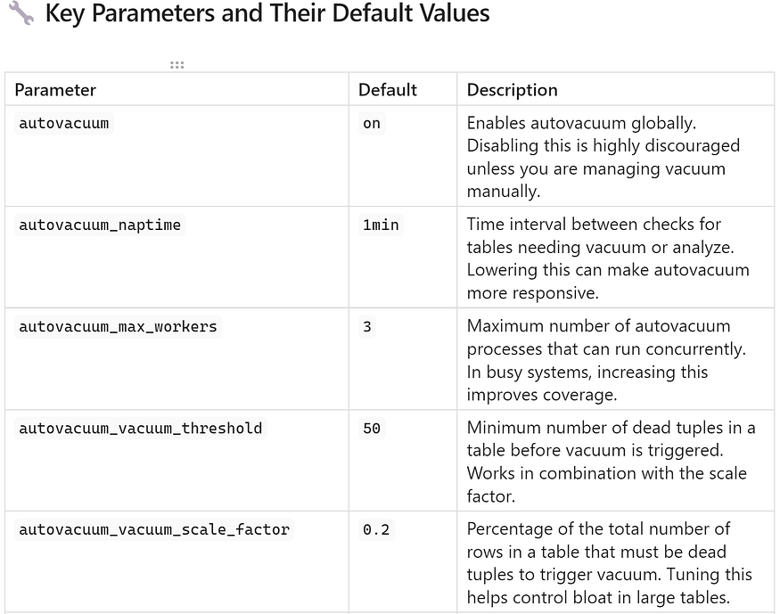

Press enter or click to view image in full size

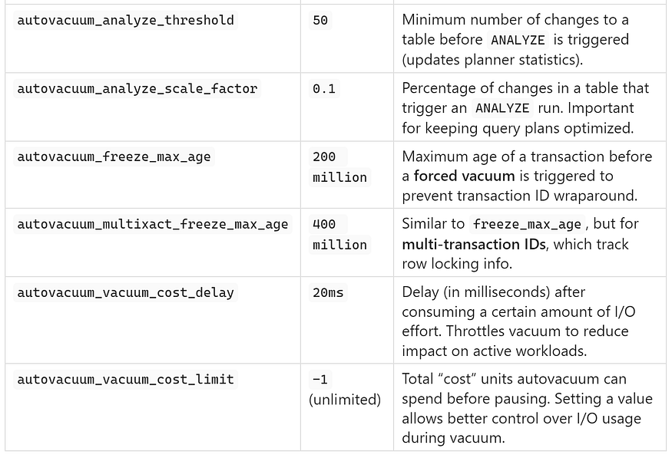

## **✅ Why Proper Tuning Matters**

In ****large or high-write PostgreSQL databases****, relying on default autovacuum settings is often insufficient. You may experience:

* ****Tables not being vacuumed in time****, leading to table bloat.
* ****Query plans becoming inefficient****, because ANALYZE isn’t triggered frequently enough.
* Risk of ****transaction ID wraparound****, if freeze vacuums aren’t executed proactively.
* ****Unbalanced autovacuum performance****, where some tables are ignored due to worker limits.

By tuning these parameters, you can:

* Reduce table bloat proactively.
* Improve query response times.
* Keep your indexes and statistics optimized.
* Prevent system outages related to wraparound failures.

## **🧠 Best Practices for Tuning**

* ****Monitor regularly****: Use views like pg_stat_user_tables and pg_stat_all_tables to watch for dead tuples and vacuum stats.
* ****Lower scale factors**** on large tables: For example, set autovacuum_vacuum_scale_factor to 0.05 for tables with millions of rows.
* ****Increase autovacuum_max_workers**** on multicore machines with many active tables.
* Use ****table-level settings**** (ALTER TABLE ... SET) to tune parameters for critical or high-activity tables individually.
* If using cloud-managed PostgreSQL (e.g., RDS/Aurora), some parameters may be modified via parameter groups.

## **🔍 Why Autovacuum is Critical in PostgreSQL**

PostgreSQL is well-known for being robust, self-healing, and reliable — and one of the key reasons for this is its ****autovacuum**** process. While it works quietly in the background, autovacuum plays a ****crucial role**** in maintaining the performance, integrity, and efficiency of your database.

Many developers and even some DBAs tend to overlook the importance of autovacuum — until problems begin to surface. Whether it’s slow queries, high disk usage, or catastrophic transaction ID wraparound, the consequences of neglected vacuuming can be serious.

Let’s dive into why autovacuum is not just useful — but ****essential**** to any healthy PostgreSQL system.

## **1️⃣ Reclaims Storage — Prevents Unbounded Table Growth**

Every time a row is ****updated or deleted****, PostgreSQL ****doesn’t immediately remove the old data****. Instead, it creates ****dead tuples**** — outdated versions of rows that are no longer needed.

If these dead tuples are not cleaned up:

* Tables ****keep growing**** in size, even if the number of live rows stays the same.
* Disk usage increases ****without any added business value****.
* Queries become slower, as PostgreSQL has to scan through unnecessary data blocks.
* Indexes grow inefficient, requiring more space and maintenance.

Autovacuum prevents this by regularly cleaning up dead tuples, allowing the database to ****reuse internal storage**** and ****maintain optimal performance**** — all without user intervention.

## **2️⃣ Prevents Transaction ID Wraparound — Protects Against Data Corruption**

PostgreSQL uses ****32-bit transaction IDs (XIDs)**** to track visibility of changes across transactions. Over time, as transactions are created, these IDs increase and eventually wrap around back to zero.

If vacuuming isn’t performed regularly:

* PostgreSQL ****loses track**** of which data is visible to which transactions.
* The system can ****no longer ensure data consistency****.
* Eventually, it ****enters emergency mode****, blocking new transactions and requiring immediate vacuuming of all tables.
* In extreme cases, it can lead to ****data corruption**** or ****forced downtime****.

Autovacuum plays a critical role here by ****freezing old tuples**** — marking them with a “safe” XID so they are no longer at risk. This process ensures that PostgreSQL can ****continue operating safely****, no matter how many transactions have occurred.

✅ This is one of the **most important reasons** not to disable autovacuum — it protects the very integrity of your database.

## **3️⃣ Keeps Statistics Fresh — Enables Smarter Query Planning**

PostgreSQL relies heavily on ****statistics**** about tables and columns to build optimal query execution plans. These statistics are updated by the ANALYZE command — which is also run automatically by autovacuum.

Fresh statistics help PostgreSQL:

* Estimate row counts more accurately.
* Choose the most efficient index or scan method.
* Avoid costly full-table scans or nested loops.

Without autovacuum running ANALYZE regularly, query plans can become outdated and suboptimal — leading to ****slower execution****, ****higher CPU usage****, and ****unexpected load**** on your database.

By automatically analyzing tables after a certain number of changes, autovacuum ensures that ****your query planner always has the best possible information****.

## **4️⃣ Avoids Manual Micromanagement — Enables Hands-Off Maintenance**

One of the greatest strengths of PostgreSQL is that, with proper configuration, it can ****manage itself reliably**** — even at scale.

Before autovacuum was introduced, DBAs had to:

* Manually run VACUUM on active tables.
* Schedule maintenance scripts during off-hours.
* Constantly monitor for bloat and wraparound risks.

Autovacuum removes the need for such micromanagement by:

* ****Monitoring all user tables**** continuously.
* ****Automatically triggering vacuum and analyze**** as needed.
* Running as a ****background daemon****, independent of user sessions.

This means you spend less time babysitting your database and more time focusing on your application — ****without sacrificing performance or safety****.

## **✅ Conclusion**

Autovacuum is not just a background task — it’s a ****cornerstone**** of PostgreSQL’s performance and reliability. It:

* Frees up space by cleaning dead tuples.
* Prevents catastrophic transaction ID overflow.
* Keeps query statistics fresh for better performance.
* Automates routine maintenance so you don’t have to.

****Disabling or ignoring autovacuum can lead to serious consequences.**** In contrast, properly tuning and monitoring it ensures that your database remains fast, stable, and resilient — even under heavy loads.

In the next section, we’ll explore how to ****monitor autovacuum activity**** and understand when you may need to intervene manually.

## **🔎 Monitoring Autovacuum Activity in PostgreSQL**

While PostgreSQL’s ****autovacuum**** process is designed to work automatically in the background, it’s important for database administrators and developers to ****monitor its activity regularly****. Why? Because in certain situations — especially in ****high-write workloads**** — autovacuum may ****fall behind****, or may not trigger often enough to prevent table bloat or transaction ID wraparound.

Monitoring autovacuum helps you identify:

* Tables that are accumulating too many dead tuples,
* Tables that haven’t been vacuumed recently,
* Whether autovacuum is enabled at all.

Here’s how you can check the health and activity of autovacuum using simple SQL queries.

## **✅ Check if Autovacuum is Enabled**

Before anything else, ensure that the autovacuum process is ****actually turned on****. While it is enabled by default in PostgreSQL, it’s always a good idea to verify — especially if you’re working on a tuned or older system.

Run the following query:

SELECT name, setting   
FROM pg_settings   
WHERE name = 'autovacuum';

* If the setting returns 'on', autovacuum is active.
* If it returns 'off', ****your database is at risk**** of bloat and transaction ID wraparound. You should enable it immediately unless you’re managing vacuuming manually.

## **📅 See Last Vacuum and Autovacuum Timestamps**

PostgreSQL tracks when each table was last vacuumed — both manually (VACUUM) and automatically (autovacuum). You can view this data using the pg_stat_user_tables system view.

Run this query:

SELECT relname, last_vacuum, last_autovacuum   
FROM pg_stat_user_tables;

This shows:

* last_vacuum: The last time someone ran a manual VACUUM on the table.
* last_autovacuum: The last time the autovacuum daemon processed the table.

By reviewing these timestamps, you can:

* Identify tables that haven’t been vacuumed in a long time.
* Detect tables that may have ****autovacuum disabled**** at the table level.
* Spot maintenance gaps and take corrective action.

💡 If critical tables show NULL for both timestamps, they might not be getting vacuumed at all.

## **🧟 Check for Dead Tuples in Tables**

The number of ****dead tuples**** in a table is a direct indicator of whether vacuuming is keeping up. Too many dead tuples = ****increased bloat****, which can slow down queries and waste disk space.

Use the following query:

SELECT relname, n_dead_tup   
FROM pg_stat_user_tables   
ORDER BY n_dead_tup DESC   
LIMIT 10;

This lists the top 10 user tables with the highest count of dead tuples.

* If a table has a ****high dead tuple count****, it may need:
* A ****manual VACUUM or VACUUM FULL****.
* ****Tuning of autovacuum settings****, like autovacuum_vacuum_scale_factor.
* Regular monitoring to see if the dead tuples persist.

🛠️ Large dead tuple counts can exist even if autovacuum is enabled — especially if thresholds are too high or worker limits are too low.

## **🔧 Tables That May Need Manual Intervention**

From the above checks, you can pinpoint ****problematic tables**** that autovacuum might be missing or processing too slowly. These tables typically:

* Show ****no recent autovacuum activity****,
* Have a ****large number of dead tuples****, and
* Experience ****frequent updates or deletes****.

For these cases, consider:

* Manually running VACUUM or VACUUM FULL during off-peak hours.
* Lowering the autovacuum_vacuum_scale_factor for the table.
* Increasing autovacuum_max_workers or reducing autovacuum_naptime globally.

## **✅ Summary**

Regularly monitoring autovacuum ensures that your PostgreSQL database stays healthy, performant, and free from excessive bloat. With just a few SQL queries, you can:

* Confirm autovacuum is enabled,
* Track recent vacuum activity,
* Detect dead tuple buildup, and
* Decide when to intervene or tune parameters.

PostgreSQL gives you the tools — it’s up to you to use them proactively.

## **🖐 When to Use Manual VACUUM in PostgreSQL**

While PostgreSQL’s ****autovacuum**** process handles most routine maintenance automatically, there are scenarios where you, as a DBA or developer, should ****manually trigger VACUUM operations**** to keep the database healthy.

## **🧹 Why Run VACUUM Manually?**

There are several cases where manual VACUUM is recommended:

* ****High-dead-tuple tables****: If autovacuum is not responding fast enough, dead tuples will accumulate and degrade performance.
* ****Before heavy update/delete operations****: If you’re about to perform batch processing, running VACUUM beforehand can ensure cleaner pages and avoid bloating.
* ****After massive updates/deletes****: Autovacuum may not be aggressive enough, and immediate cleanup is necessary.

## **🔍 VACUUM (VERBOSE, ANALYZE)**

VACUUM (VERBOSE, ANALYZE);

* ****VERBOSE****: Displays detailed information about the vacuum operation in your logs, including how many dead tuples were removed and which tables were processed.
* ****ANALYZE****: Refreshes statistics for the PostgreSQL query planner after cleanup. This helps the optimizer choose better query execution paths for future queries.

Use this version when you want ****both cleanup and updated planner statistics****, especially after bulk operations.

## **🧱 VACUUM FULL: For Severe Bloat and Disk Reclamation**

VACUUM FULL;

Use this when:

* Tables are severely bloated.
* You need to ****physically shrink table and index files**** to reclaim disk space.
* You’re preparing for a ****database migration****, cleanup, or storage optimization task.

🚨 **Caution**: VACUUM FULL rewrites the entire table and **requires an exclusive lock**. This means:

* No reads or writes can happen during its execution.
* On large tables, the operation can take time and temporarily block access.

Always run VACUUM FULL during low-traffic hours or in scheduled maintenance windows.

## **🚨 What Happens If You Ignore Vacuuming?**

Vacuuming isn’t just a routine cleanup task — it’s ****central to PostgreSQL’s architecture****. Failing to vacuum regularly leads to multiple serious issues:

## **📦 1. Table Bloat Grows Uncontrollably**

Without vacuuming, dead tuples ****accumulate**** indefinitely. The result is:

* Tables and indexes grow much larger than necessary.
* Storage is wasted.
* Queries take longer due to more I/O reads.

## **🐢 2. Queries Slow Down**

As bloat increases:

* Sequential scans must process more pages filled with dead tuples.
* Index lookups become inefficient due to outdated entries.
* Query planners may choose suboptimal plans because of skewed statistics.

Over time, your once-snappy queries turn sluggish.

## **💣 3. Transaction ID Wraparound Risk**

PostgreSQL assigns a unique 32-bit ****transaction ID (XID)**** to each transaction. These IDs eventually ****wrap around**** (~4 billion transactions). If old tuples aren’t frozen (which vacuuming does), PostgreSQL:

* Can’t determine row visibility accurately.
* May enter emergency mode to ****protect data integrity****.
* In extreme cases, the database will ****refuse new writes**** or even shut down.

🔑 PostgreSQL depends on **vacuuming for survival**. It’s not optional — it’s essential for long-term database **health and safety**.

## **✅ Quick Cheat Sheet Summary**

Here’s a handy reference for working with vacuum in PostgreSQL:

🔧 Action ✅ Command Run normal vacuum VACUUM; Run vacuum with stats update VACUUM (ANALYZE); Run full vacuum (reclaim disk) VACUUM FULL; See tables with dead tuples Query pg_stat_user_tables Check autovacuum status Query pg_settings and pg_stat_user_tables

## **✅ Bonus Tip**

For targeted tuning, you can set per-table autovacuum settings like this:

ALTER TABLE your_table SET (  
 autovacuum_vacuum_scale_factor = 0.05,  
 autovacuum_vacuum_threshold = 100  
);

This makes autovacuum respond more aggressively on high-write tables without affecting the rest of the database.

## **🔧 Tuning Autovacuum for High-Write Systems**

In ****write-heavy PostgreSQL environments**** — such as OLTP systems, SaaS platforms, or real-time APIs — ****autovacuum’s default behavior may not be aggressive enough**** to keep up with the volume of inserts, updates, and deletes. When autovacuum lags behind, tables can quickly become bloated, queries slow down, and the risk of transaction ID wraparound increases.

To address this, PostgreSQL provides a set of ****tunable parameters**** that allow you to ****accelerate autovacuum behavior**** for high-throughput workloads.

## **⚙️ Recommended Parameter Adjustments**

Here are a few key settings you can adjust using the ALTER SYSTEM command. These changes are applied at the ****cluster level****, so they affect all databases unless overridden at the table level.

ALTER SYSTEM SET autovacuum_vacuum_scale_factor = 0.05;

* Reduces the default percentage of dead tuples required to trigger a vacuum.
* The default is 0.2 (20% of the table), but 0.05 makes autovacuum respond after only 5%.
* Helps prevent ****bloat from growing unchecked**** in large, frequently updated tables.

ALTER SYSTEM SET autovacuum_analyze_scale_factor = 0.02;

* Reduces the threshold for when autovacuum runs ANALYZE to update planner statistics.
* A smaller value ensures ****query plans stay accurate and optimized****, especially when data changes rapidly.

ALTER SYSTEM SET autovacuum_max_workers = 10;

* Increases the number of concurrent autovacuum workers.
* The default is 3, which may be insufficient in environments with many active tables.
* Boosting this value enables ****more tables to be vacuumed in parallel****, keeping pace with write activity.

ALTER SYSTEM SET autovacuum_naptime = '30s';

* Reduces the interval between autovacuum sweeps from the default of 1 minute to 30 seconds.
* This allows PostgreSQL to ****check more frequently**** for tables that need vacuuming or analyzing.

⚠️ **Important Note**: While these settings can significantly improve responsiveness in high-write systems, they may also **increase I/O load**. Always **test configuration changes in a staging environment** first to avoid negative performance impact in production.

## **🏁 Conclusion: Vacuum is Not Optional in PostgreSQL**

Whether you’re managing a small analytics workload or a massive transactional database, one thing is true:

🧠 **PostgreSQL relies on vacuuming to function reliably over time.**

Ignoring vacuum behavior — or failing to tune autovacuum for your workload — can result in:

* ****Severe table bloat****
* ****Slower query performance****
* ****Excessive disk usage****
* ****Unexpected downtime****
* And even ****data corruption risk**** due to transaction ID wraparound

The more you understand and control autovacuum, the better you’ll be able to:

✅ Optimize overall system performance  
✅ Avoid outages caused by bloat or wraparound  
✅ Save money on storage and backup sizes  
✅ Protect the long-term health of your data

## **🧰 Final Advice**

Treat autovacuum as a ****core part of your PostgreSQL architecture****, not just a background process. It’s your database’s built-in cleaner, optimizer, and safety net — all rolled into one.

****Tune it. Monitor it. Trust it.****  
Your database — and your users — will thank you.